**Q1. Type of Triangle**

Write a query identifying the type of each record in the TRIANGLES table using its three side lengths. Output one of the following statements for each record in the table:

**Equilateral**: It's a triangle with **3** sides of equal length.

**Isosceles**: It's a triangle with **2** sides of equal length.

**Scalene**: It's a triangle with **3** sides of differing lengths.

**Not A Triangle**: The given values of A, B, and C don't form a triangle.

The TRIANGLES table is described as follows:

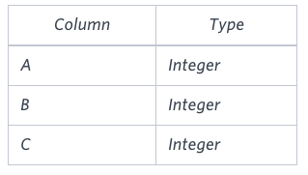

Each row in the table denotes the lengths of each of a triangle's three sides.

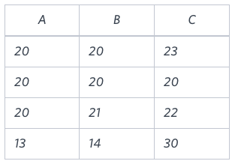**Sample Input**

**Sample Output**

Isosceles

Equilateral

Scalene

Not A Triangle

**Explanation**

Values in the tuple **(20,20,23)** form an Isosceles triangle, because **A ≡ B**.

Values in the tuple **(20,20,20)** form an Equilateral triangle, because **A ≡ B ≡ C**.

Values in the tuple **(20,21,22)** form a Scalene triangle, because **A ≠ B ≠ C**.

Values in the tuple **(1,14,30)** cannot form a triangle because the combined value of sides **A** and **B** is not larger than that of side **C**.

**Ans**.

SELECT

CASE WHEN (A+B>C) AND (B+C>A) AND (A+C>B) THEN

CASE

WHEN (A=B) AND (B=C) AND (A=C) THEN 'Equilateral'

WHEN (A=B) OR (B=C) OR (A=C) THEN 'Isosceles'

ELSE 'Scalene' END

ELSE 'Not A Triangle' END

FROM TRIANGLES